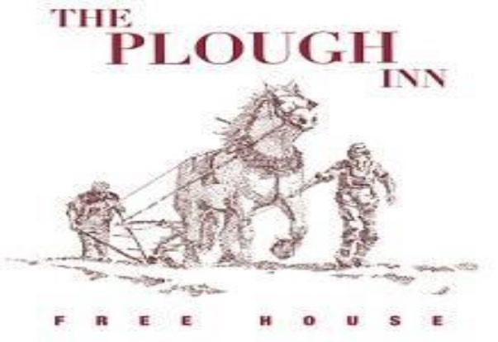

Snacks: Mixed olives £4.50 /Char grilled bread, olive oil & balsamic £4.50

STARTERS

Seasonal Soup of The Day (VG) £7.50
Salmon Gravlax , Dill Sour Cream and House Baked Soda Bread £10
Chicken and Pea Samosas with Mint and Yoghurt Dip (Vegetarian On Request) £7.50
Baked Camembert to Share £16

MAINS

Fish and Chips £18.50
Surrey Farm Roast Beef, Horseradish Cream £22
Roast Rare Breed Pork, Apple Sauce and Crackling £20
Roast Lemon Chicken and Stuffing £20
Root Vegetable Wellington, Sesame and Poppy Seeds £17
Sunday Roast Trio £26

SIDES

Duck Fat Potatoes £5, Cauliflower Cheese for two £7, Chips £4.50, Cheesy Chips £5.50

DESSERTS

Sticky Toffee Pudding served with toffee sauce and vanilla ice cream £8.50
Seasonal Crumble served with custard £7.50
Chocolate Brownie with Vanilla Ice Cream £8.50
Ice cream selection £2.50 per scoop – ask your server for today’s flavours
Local Cheese Selection £14

We are happy to provide allergen guidelines for all our menu items. We take additional measures when told about allergens but as our food is prepared and freshly cooked to order in our kitchen, we cannot guarantee all traces of allergens and gluten are removed.
An optional discretionary 12.5% service charge will be added to the bill.

